BME170
EEG Lab
Recording and Analysis of Human EEG Signals
Assigned Day: Week 3 and Week 4 - Thursday
Author: Brian Ngo
Partner(s): Katherine Sikorski
EEG Data Source Eyes Experiment: Katherine Sikorski
EEG Data Source Grasp Experiment:
Lab Date: 17/2025 and 4/24/2025

FileName: <73095898>_EEGLab_Report.docx

I affirm, under the law of penalty, that I completed the entire lab report on my own.
by following the UCI Academic Integrity Policy at https://aisc.uci.edu/students/academic-integrity/index.php.

Introduction
Electroencephalography (EEG) is a non-invasive technique used to measure the brain's electrical activity through electrodes placed on the scalp. It is commonly employed in the diagnosis of neurological conditions such as motor function abnormalities and sleep disorders. The EEG cap ensures accurate electrode placement over regions of the scalp corresponding to areas of significant cortical activity.
In this experiment, signals were recorded from the O1, O2, C3, and C4 electrode positions. The raw electrical signals are typically amplified and filtered, producing oscillatory waveforms that can be categorized by frequency into five primary types: Delta (0–4 Hz), Theta (4–8 Hz), Alpha (8–12 Hz), Beta (12–40 Hz), and Gamma (40–100 Hz). Alpha waves are associated with a calm, relaxed, yet alert mental state, while μ-rhythms (mu rhythms), typically in the 8–12 Hz range, are linked to motor cortex activity and are suppressed during movement.
This lab consisted of two parts. In Part A, the focus was on detecting and modulating alpha rhythms. Since alpha activity is known to increase when the eyes are closed and the subject is relaxed and decrease when the eyes are open and engaged in mental activity, alternating between these states allowed for the observation of alpha rhythm modulation. In Part B, the experiment investigated μ-rhythm suppression during voluntary movement using a hand grasp-relax protocol. The subject alternated between repetitively grasping and relaxing their right hand while EEG signals were recorded, enabling analysis of how motor activity affects neural oscillations in sensorimotor regions.
Materials
The following materials were used to conduct the EEG experiment:
Data Acquisition Equipment:
- MP150 data acquisition unit
- Universal Interface Module 100C
- 4 × EEG100C amplifiers
EEG Setup:
- EEG cap with integrated cables
- Electrode adapter
- Conductive gel
- Syringe (for gel application)
- Measurement tape (for measuring head size and accurate electrode placement)
Audio Equipment:
- Headphones
Software:
- AcqKnowledge software (for signal acquisition and analysis)
- MATLAB software (for post-processing and data visualization)
Methods
Two individuals participated in this study: one functioned as the subject, while the other served as the experiment conductor. The experiment consisted of two parts: Experiment A, which focused on alpha rhythm modulation during eyes-open and eyes-closed intervals, and Experiment B, which investigated motor-related μ-rhythm activity during hand grasping and relaxation.
Experiment A: Alpha Rhythm Detection
The EEG setup began with proper cap placement on the subject's scalp. Conductive gel was injected into each electrode using a syringe to ensure low impedance. The EEG cap was connected to four EEG100C amplifiers, the MP150 data acquisition system, and a pair of headphones for “open” and “close” audio cue directions. The signal gain was set to 20,000, with a low-pass filter at 35 Hz and a high-pass roll-off at 0.5 or 1 Hz on the amplifiers. Electrodes at sites O1, O2, C3, and C4 were used for signal acquisition, with a ground (GND) electrode for reference.
Once the hardware setup was verified, the subject was seated comfortably, and the AcqKnowledge software was launched to confirm signal quality. The subject was asked to relax with their eyes closed while alpha rhythms were visually inspected in real-time EEG traces. Upon confirmation of consistent alpha activity, the open_close_protocol.m MATLAB was opened. The test consisted of 10 alternating trials of eyes-open and eyes-closed intervals, each lasting 15 and 30 seconds, respectively.
The subject received audio prompts through headphones, instructing them when to open or close their eyes. During eyes-closed periods, the subject was instructed to relax completely, while during eyes-open periods, they were asked to remain still to suppress alpha activity (Subject reported doing mental math). Movement was minimized throughout the experiment to avoid motion artifacts. After completion, data was exported as a .mat file for further analysis using MATLAB.
Experiment B: Hand Grasp-Relax Protocol
The second phase of the experiment aimed to investigate μ-rhythm activity in the sensorimotor cortex during voluntary motor engagement. As in Experiment A, the EEG cap was properly fitted and prepared using conductive gel, and the same electrode sites (O1, O2, C3, C4, and GND) were used. The subject remained seated, with the EEG signals continuously monitored via AcqKnowledge, and auditory instructions delivered through headphones.
The experiment was controlled using the MATLAB script hand_protocol.m, which played a sequence of audio cues prompting the subject to either “Repeatedly Grasp Hand” or “Open and Relax Hand.” During the grasp periods, the subject repeatedly clenched their right hand (i.e., made and released a fist) while keeping the rest of their body relaxed and still. During the relaxing periods, the hand was kept open, and the subject remained motionless. Throughout the entire task, the subject was instructed to try to keep their eyes open to avoid introducing alpha rhythm artifacts from visual inattention.
Each trial consisted of a 10-second grasp interval followed by a 10-second relax interval. A total of 10 trials were conducted. After confirming that the subject could consistently follow the protocol, the EEG data were recorded and later saved as a MATLAB .mat file using the standard naming format: SubjectName_Date_Grasp_Experiment.mat.
Results
The EEG data recorded using AcqKnowledge was exported as a .mat file and analyzed in MATLAB using the analyze_data function. During analysis, a sound versus time plot (Figure 1) was used to determine the timing of auditory prompts that instructed the subject to alternate between eyes-open and eyes-closed states. A threshold value of 0.066711 V was selected to accurately identify all peaks corresponding to these audio cues.
The resulting estimated durations for each interval were approximately 29 seconds for eyes closed and 9 seconds for eyes open, consistent with the intended 30/10-second protocol. Minor differences are attributed to reaction time latency. To confirm signal quality, a Parseval test was applied, comparing energy values in the time and frequency domains. The ratios remained near 1.000 across all trials and channels, indicating accurate spectral decomposition and reliable data.
Following preprocessing, power spectral density (PSD) plots were generated for each EEG channel. Figure 2 shows combined PSD plots across all four channels. A clear increase in alpha-band power (8–12 Hz) during the eyes-closed state is most evident in channels O1 and O2. This is further supported by individual channel PSD plots (Figures 3a-d), where the eyes-closed condition (blue) exhibits strong peaks between 10–11 Hz, characteristic of alpha rhythms. In contrast, the eyes-open condition (red) shows a marked reduction in power within this frequency band.
Notably, O1 (Figure 3) and O2 (Figure 3b) channels demonstrated the highest alpha wave activity, while channels C3 (Figure 3c) and C4 (Figure 3d) showed minimal or inconsistent alpha power changes. This is likely due to anatomical factors or suboptimal electrode contact at central scalp regions, potentially affected by hair density or insufficient conductive gel.
Quantitative power values for each trial are presented in Table 1. Mean alpha power increased from 7.15 × 10⁻⁶ (open) to 1.34 × 10⁻⁴ (closed) in O1, and from 6.67 × 10⁻⁶ to 8.95 × 10⁻⁵ in O2. C3 and C4 channels showed smaller differences, with less consistent alpha activity across trials.
To determine statistical significance, a two-sided sign test was performed. As shown in Table 2, all four channels returned p-values < 0.05, with h-values = 1, supporting rejection of the null hypothesis that median alpha power is the same in open and closed states. To confirm directionality, a one-sided (right-tailed) sign test was conducted, yielding even lower p-values (Table 3), reinforcing the conclusion that alpha power significantly increases during eyes-closed conditions.
The second part of the experiment aimed to observe μ-rhythm modulation during alternating hand grasp and relaxation tasks. After collecting EEG data over 10 grasp/relax trials, the .mat file was analyzed using the analyze_data_hand.m MATLAB script. A threshold of 0.091594 V was selected to accurately mark the audio cue peaks (Figure 4).
The durations of the detected intervals matched expectations, with average grasp and relaxation periods of 9 seconds each. A Parseval test was performed across all channels and trials, and energy ratios remained close to 1.000, indicating signal integrity between time and frequency domains.
PSD plots were generated to visualize μ-band activity (8–12 Hz). Figure 5 shows a summary PSD for all channels, highlighting overall μ-power changes. Subfigures 6a–6d present individual channel comparisons for grasp versus relax conditions. In Channel C3 (Figure 6c) and Channel C4 (Figure 6d), μ-power significantly decreased during hand grasping, which is consistent with motor-related μ-desynchronization in the sensorimotor cortex. Occipital channels O1 (Figure 6a) and O2 (Figure 6b) also exhibited μ-desynchronization, though to a lesser extent, possibly due to volume conduction or generalized cortical engagement. Quantitatively, the mean μ-power during grasp was consistently higher than during relaxation for all channels:
O1: grasp = 1.06 × 10⁻⁵, relax = 4.44 × 10⁻⁶
O2: grasp = 9.59 × 10⁻⁶, relax = 3.87 × 10⁻⁶
C3: grasp = 6.63 × 10⁻⁶, relax = 2.69 × 10⁻⁶
C4: grasp = 6.44 × 10⁻⁶, relax = 2.20 × 10⁻⁶
These results support the hypothesis that repetitive motor activity (grasping) leads to μ-rhythm suppression (desynchronization), especially in the sensorimotor regions. Small variations in signal amplitudes across trials may be attributed to subject fatigue, variability in task execution, or residual motion artifacts.
Conclusion
This experiment introduced students to fundamental EEG acquisition and analysis techniques through two complementary protocols targeting alpha and μ-rhythms. In Part A, EEG signals were recorded during alternating eyes-open and eyes-closed intervals to examine changes in alpha activity associated with visual attention and relaxation. In Part B, a hand grasp-relax task was conducted to explore μ-rhythm suppression during voluntary motor activity.
Results from Part A confirmed a marked increase in alpha power during the eyes-closed condition, particularly in occipital channels O1 and O2, consistent with expected neurophysiological responses. Statistical analysis yielded p-values below 0.05 across all channels, supporting the rejection of the null hypothesis and validating the ability of EEG to capture alpha modulation due to sensory input changes.
Part B revealed that μ-rhythm power was higher during periods of hand relaxation and consistently suppressed during hand grasping trials. These changes were evident in both occipital and central channels, particularly C3 and C4, which are associated with motor cortex activity. The results align with known patterns of event-related desynchronization in EEG literature, supporting the effectiveness of the protocol.
Some inconsistencies, especially in central electrodes, likely stemmed from imperfect electrode contact, movement artifacts, or variations in subject compliance. These limitations highlight the importance of proper cap fitment, generous conductive gel application, and minimizing body movement. To improve data fidelity in future sessions, students may consider using scalp preparation techniques, optimizing electrode placement, and repeating trials to ensure consistency. This lab successfully demonstrated how EEG can be used to monitor and interpret both sensory-related and motor-related brain activity in real-time, providing a practical foundation for further exploration in neurophysiological recording and analysis.
Figures
Figure 1. Audio signals show sound voltage over time. Each red vertical line represents the threshold-detected onset of an auditory cue prompting the subject to open or close their eyes. The dotted horizontal line indicates the selected threshold value (0.066711 V).
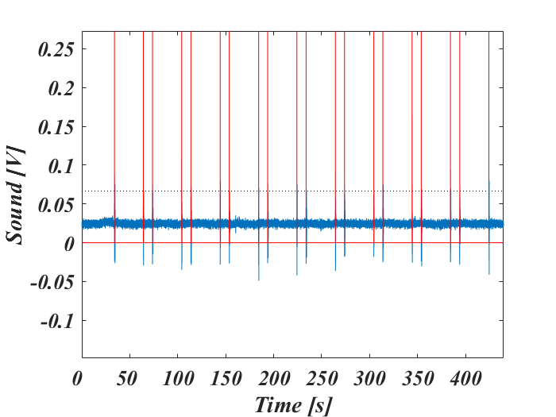
Figure 2. Power spectral density (PSD) plots for all four EEG channels (O1, O2, C3, C4). Blue represents eyes-closed intervals and red represents eyes-open intervals. Higher alpha-band activity is visible during eyes-closed trials on the occipital channels.
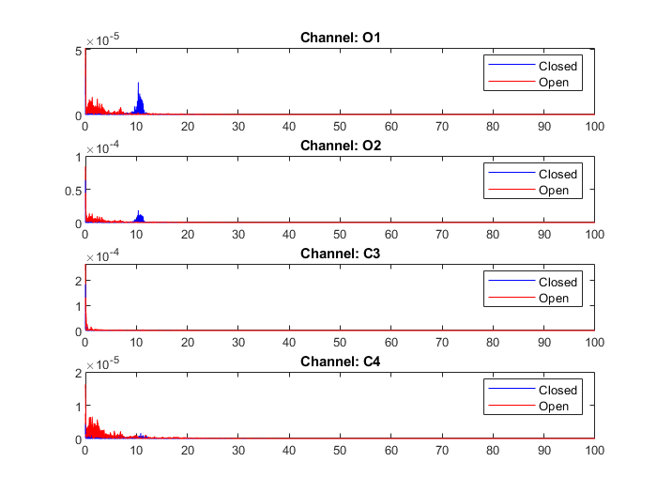
Figure 3a. Channel O1 PSD comparison between eyes-open and eyes-closed states. A strong peak is observed in the 10–11 Hz range during the eyes-closed condition, indicative of alpha rhythm dominance. Figure 3b. Channel O2 PSD comparison. Similar to O1, alpha activity increases significantly during the eyes-closed state, peaking around 10–11 Hz. Figure 3c. Channel C3 PSD comparison. Unlike the occipital channels, C3 shows minimal distinction in alpha power between conditions, with a slight increase in eyes-open data, potentially due to noise or poor contact. Figure 3d. Channel C4 PSD comparison. Alpha activity is less prominent and more variable, reflecting potential interference or suboptimal electrode placement.
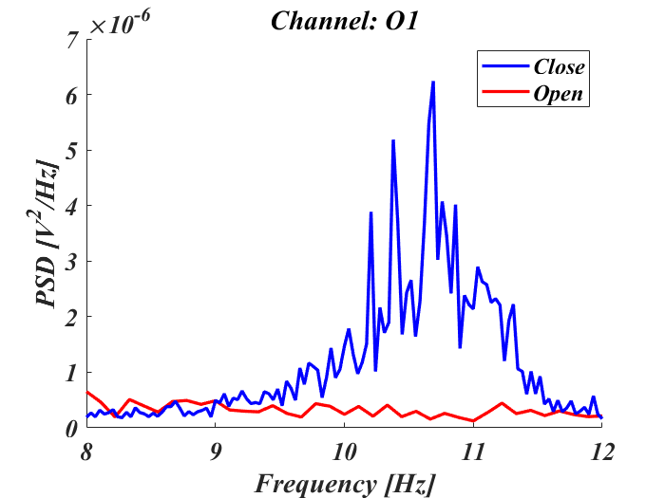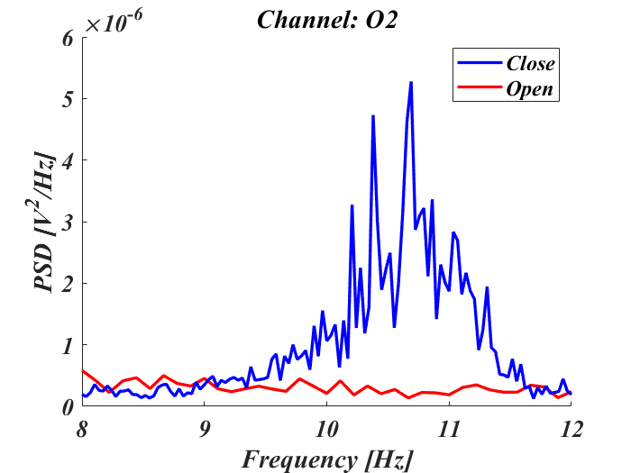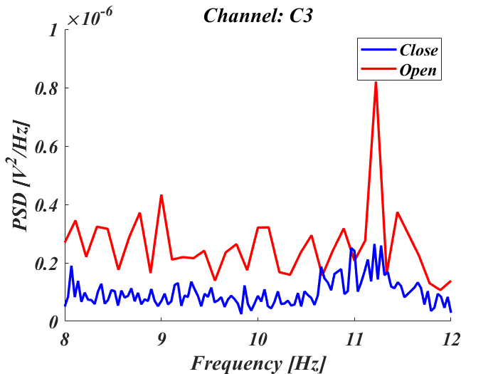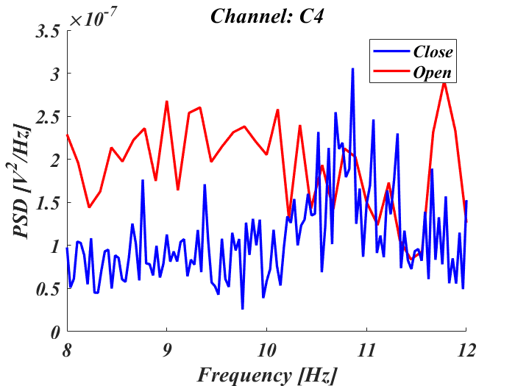
Figure 4. Audio signal trace for the hand grasp-relax experiment. Vertical red lines denote detected sound peaks used to mark trial transitions. The horizontal dotted line shows the selected threshold (0.091594 V).
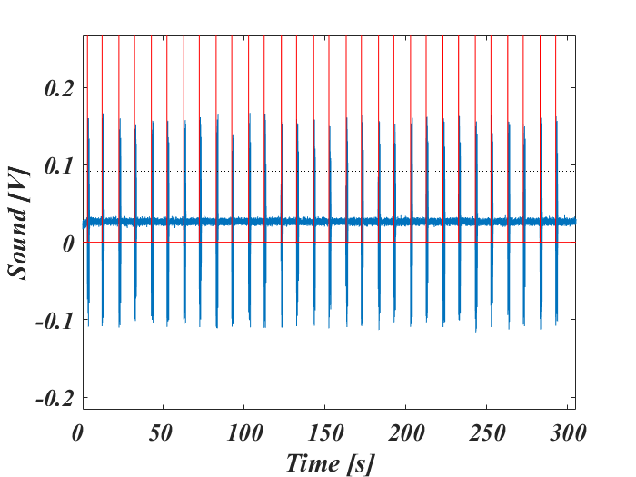
Figure 5. Power spectral density plots across all channels during grasp (blue) and relax (red) conditions. A notable decrease in μ-power is visible during grasping, particularly around 10 Hz.
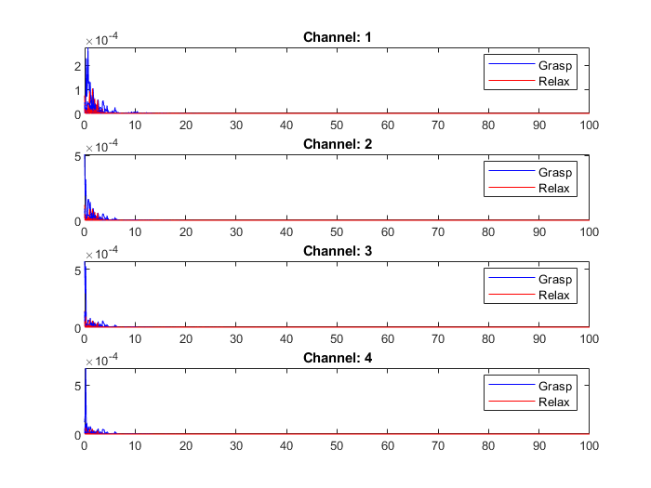
Figure 6a. Channel O1: PSD comparison between hand grasp and relax periods. Figure 6b. Channel O2: PSD comparison showing moderate μ-desynchronization during grasp. Figure 6c. Channel C3: Clear μ-suppression during grasping, consistent with motor cortex involvement. Figure 6d. Channel C4: Similar μ-desynchronization pattern during hand movement.
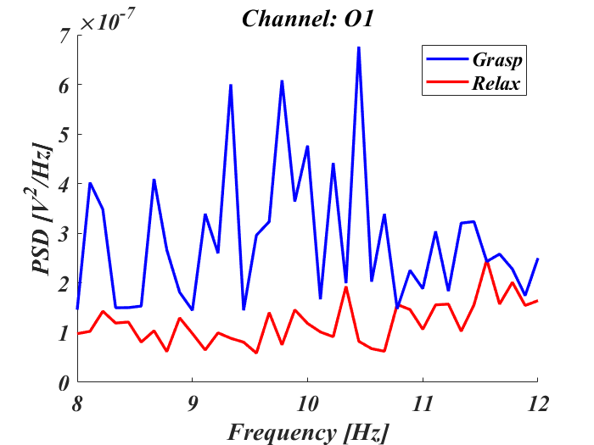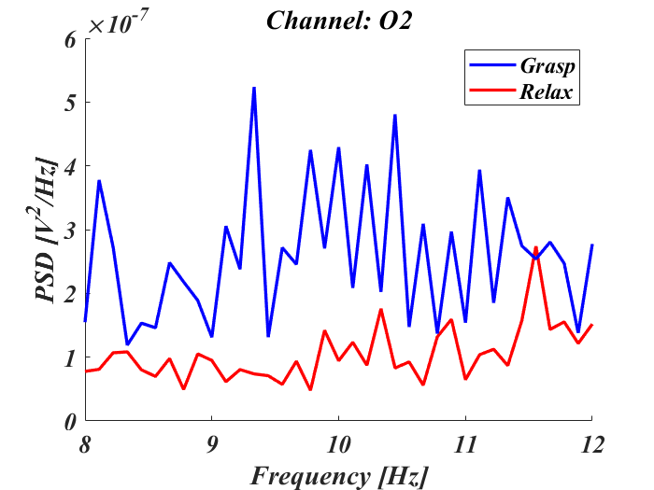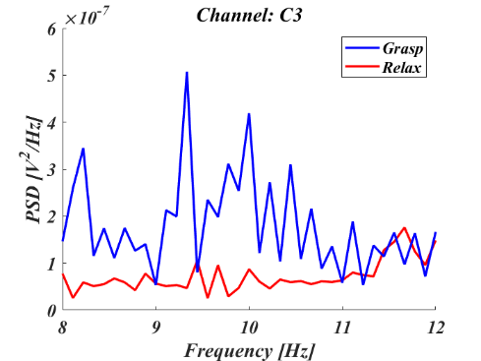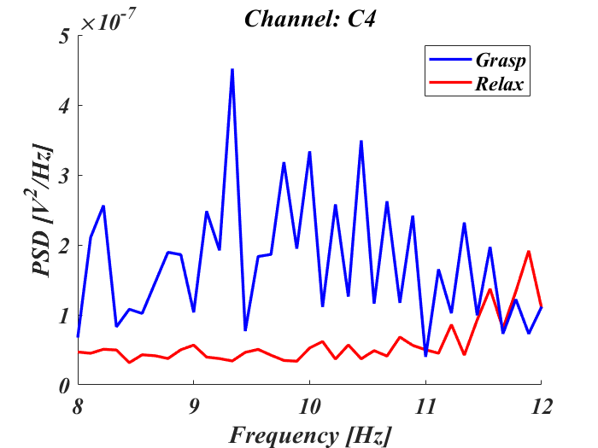

Tables

Table 1. All power and mean power values from all 4 channels for all 10 trials for both eyes open and closed scenarios.
Trial # | Power O1  Open (e-5) | Close (e-3) | Power O2  Open (e-5) | Close (e-3) | Power C3  Open (e-5) | Close (e-3) | Power C4  Open (e-5) | Close (e-3)
1 | 0.7015 | 0.1763 | 0.8802 | 0.1266 | 0.3412 | 0.0037 | 0.3981 | 0.0062
2 | 0.7799 | 0.145 | 0.7159 | 0.0686 | 0.2037 | 0.0036 | 0.1707 | 0.0052
3 | 0.5672 | 0.2041 | 0.6842 | 0.1444 | 0.2323 | 0.0051 | 0.2408 | 0.0063
4 | 0.9733 | 0.1218 | 0.854 | 0.079 | 0.336 | 0.0052 | 0.373 | 0.0054
5 | 0.6349 | 0.1349 | 0.3997 | 0.0715 | 0.1708 | 0.005 | 0.1623 | 0.0057
6 | 0.8321 | 0.115 | 0.6277 | 0.0872 | 0.2037 | 0.0027 | 0.2539 | 0.0057
7 | 0.7906 | 0.0792 | 0.7454 | 0.0502 | 0.1951 | 0.0027 | 0.2838 | 0.0018
8 | 0.7145 | 0.1066 | 0.7505 | 0.0657 | 0.2267 | 0.0026 | 0.2639 | 0.0048
9 | 0.5712 | 0.0959 | 0.3845 | 0.0615 | 0.1466 | 0.0045 | 0.2308 | 0.0052
10 | 0.5961 | 0.1609 | 0.6292 | 0.1398 | 0.2542 | 0.0043 | 0.2532 | 0.007
Mean | 7.15e-6 | 1.34e-4 | 6.67e-6 | 8.945e-5 | 2.31e-6 | 3.94e-6 | 2.63e-6 | 5.34e-6

Table 2. p and h values because of running shows that the null hypothesis can be rejected.
Statistical Analysis | O₁ | O₂ | C₃ | C₄
p | .002 | .002 | .002 | .0215
h | 1 | 1 | 1 | 1

Table 3. p and h values because of running right-tailed showing further supports rejecting the null hypothesis.
Statistical Analysis  (right tail test) | O₁ | O₂ | C₃ | C₄
p | 9.7656e-04 | 9.7656e-04 | 9.7656e-04 | .0107
h | 1 | 1 | 1 | 1

Table 4. μ-rhythm Power Values During Hand Grasp and Relaxation
Trial # | O1 Grasp (e-5) | O1 Relax (e-4) | O2 Grasp (e-5) | O2 Relax (e-4) | C3 Grasp (e-5) | C3 Relax (e-4) | C4 Grasp (e-5) | C4 Relax (e-4)
1 | 0.5360 | 0.8377 | 0.4476 | 0.7544 | 0.6874 | 0.7213 | 0.3171 | 0.6929
2 | 0.4897 | 0.0434 | 0.4374 | 0.0324 | 0.1771 | 0.0146 | 0.1420 | 0.0149
3 | 0.6414 | 0.0463 | 0.6296 | 0.0400 | 0.3246 | 0.0200 | 0.3076 | 0.0195
4 | 0.4254 | 0.0785 | 0.3934 | 0.0611 | 0.2308 | 0.0212 | 0.2320 | 0.0204
5 | 0.4472 | 0.0333 | 0.3969 | 0.0273 | 0.2565 | 0.0153 | 0.2957 | 0.0154
6 | 0.3757 | 0.0570 | 0.2893 | 0.0484 | 0.3157 | 0.0223 | 0.3996 | 0.0243
7 | 0.3206 | 0.0538 | 0.2917 | 0.0426 | 0.4170 | 0.0236 | 0.2310 | 0.0209
8 | 0.5569 | 0.0569 | 0.5276 | 0.0639 | 0.2603 | 0.0204 | 0.1773 | 0.0279
9 | 0.3642 | 0.0838 | 0.2605 | 0.0876 | 0.1533 | 0.0241 | 0.1527 | 0.0292
10 | 0.3739 | 0.0708 | 0.2598 | 0.0591 | 0.1480 | 0.0257 | 0.0844 | 0.0257
11 | 0.2814 | 0.0443 | 0.2742 | 0.0525 | 0.2616 | 0.0158 | 0.1393 | 0.0151
12 | 0.4810 | 0.0388 | 0.4861 | 0.0363 | 0.1931 | 0.0124 | 0.2539 | 0.0149
13 | 0.4895 | 0.0530 | 0.3187 | 0.0495 | 0.2757 | 0.0203 | 0.2012 | 0.0177
14 | 0.3467 | 0.0484 | 0.3525 | 0.0451 | 0.1825 | 0.0185 | 0.2148 | 0.0134
15 | 0.5260 | 0.0501 | 0.4449 | 0.0381 | 0.1507 | 0.0194 | 0.1554 | 0.0131

